Understanding of Hardware and Its Components
Section 1: Multiple Choice
1. Which of the following is NOT a component of the CPU?
1. ALU
2. RAM
3. CU
4. 1and 3both
ANS=(2) RAM
2.What is the function of RAM in a computer?
ANS=RAM is a crucial component of a computer's hardware. Its primary function is to store data temporarily while the computer is running, allowing for fast access and processing of information.
3. Which of the following is a primary storage device?
1. HDD
2. SSD
3. SDcard
4. 1and 2both
ANS=4. 1and2both
4. What is the purpose of a GPU?
ANS=A GPU is designed to accelerate graphics rendering, gaming performance, and computational tasks, offloading intense calculations from the CPU for faster processing.
Section 2: True or False
5. True or False: The motherboard is the main circuit board of a computer
where other components are attached.
ANS=True
6. True or False: A UPS (Uninterruptible Power Supply) is a hardware
device that provides emergency power to a load when the input power
source fails.
ANS=True
7. True or False: An expansion card is a circuit board that enhances the
functionality of a component.
ANS=True
Section 3: Short Answer
8. Explain the difference between HDD and SSD.
ANS=HDD uses spinning disks and mechanical heads to store data, while SSD uses flash memory to store data. SSDs are faster, more reliable, and energy-efficient, while HDDs offer higher storage capacity at a lower cost per GB. In short:
HDD: Spinning disks, mechanical heads, slower access times
SSD: Flash memory, faster access times, lower latency
9. Describe the function of BIOS in a computer system.
ANS=BIOS initializes hardware, loads the operating system, and configures settings, acting as a "middleman" between hardware and OS, ensuring a smooth boot process.
10. List and briefly explain three input devices commonly used with
computers.
ANS=Here are three input devices commonly used with computers:
1. Keyboard: Enters text and commands into the computer.
2. Mouse: Controls the cursor and interacts with graphical user interfaces.
3. Scanner: Captures images or text from physical documents into digital format.
Section 4: Practical Application
11. Identify and label the following components on a diagram of a
motherboard:
· CPU
· RAMslots
· SATAconnectors
· PCI- 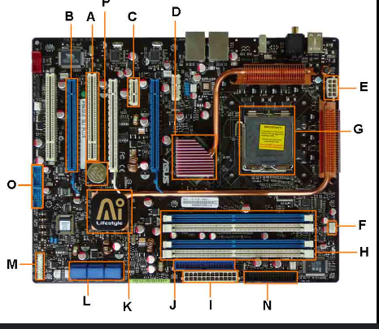
E slot
ANS=G=CPU
H=RAM SLOTS
L=SATA CONNECTORS
A&B=PCI-E SLOT
12. Demonstrate how to install a RAM module into a computer.
ANS= Here's a concise guide to installing a RAM module:
1. Shut down the computer and unplug the power cord.
2. Locate the RAM slots on the motherboard.
3. Open the slot by pulling the tabs outward.
4. Align the RAM module's notches with the slot's keys.
5. Insert the module at a 45-degree angle and apply even pressure until it clicks.
6. Secure the module by pushing the tabs back inward.
7. Boot the computer and check the BIOS settings to ensure recognition.

Section 5: Essay
13. Discuss the importance of proper cooling mechanisms in a computer
system. Include examples of cooling methods and their effectiveness.
ANS= Proper cooling mechanisms are vital in computer systems to prevent overheating, which can lead to damage, slowdowns, and failures. Effective cooling methods include air cooling (heat sinks, fans), liquid cooling (water cooling, AIO coolers), and hybrid solutions. These methods help maintain optimal temperatures, ensuring system stability, performance, and longevity. For example, a good CPU cooler can reduce temperatures by up to 30°C, while a well-designed liquid cooling system can lower GPU temperatures by up to 40°C, significantly improving overall system reliability and performance.
14. Explain the concept of bus width and its significance in computer
architecture.
ANS= Bus width refers to the number of bits that can be transmitted simultaneously over a computer's bus, a communication pathway between components. A wider bus width allows for more data to be transferred at once, increasing bandwidth and overall system performance. For example, a 64-bit bus can transfer 64 bits of data at a time, while a 32-bit bus can only transfer 32 bits. A wider bus width is significant as it enables faster data transfer, improved processing efficiency, and enhanced overall system capabilities. This is particularly important in applications requiring high-speed data processing, such as gaming and video editing.

